What is Fuzzy logic?
- Fuzzy logic is a mathematical approach that handles ambiguity and uncertainty by using degrees of truth, rather than absolute true or false, like classical logic.
- Developed by Lotfi Zadeh in the 1965
- It uses "fuzzy sets" and a "membership function" to assign values between 0 (completely false) and 1 (completely true).
- Example:
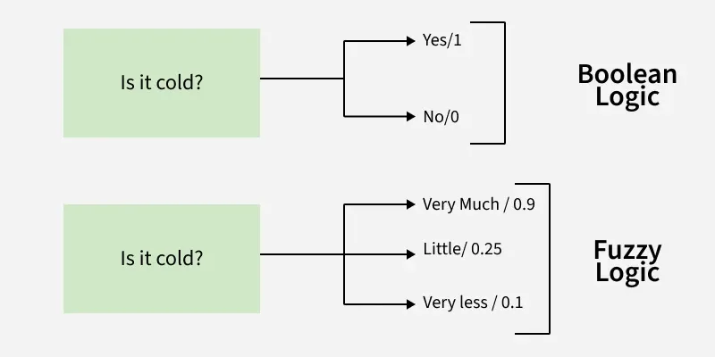

Fuzzy Logic Example

Concepts of Fuzzy Logic
Membership Function:
- It defines how much an input belongs to a particular category.
- Example, in a fuzzy temperature control system, a temperature of 70°F might belong 0.8 to the "warm" category and 0.2 to the "cool" category.
- A membership function describes how much an input value belongs to a fuzzy set. It assigns a value between 0 and 1 to each point in the input space also called the universe of discourse.
- Degree of membership ranges from 0 to 1
- represents no membership, 1 represents full membership
Intermediate values indicate partial membership
- Membership functions can overlap, allowing an input to belong to multiple fuzzy sets simultaneously.
- Membership degrees are calculated based on the shape and parameters of the membership function.
- Mathematical formulas or lookup tables are used to compute the membership value.

Fuzzy Sets:
- These are sets where elements have degrees of membership.
- Example, the "young" age group might include someone who is 30 with 0.7 membership (mostly young) and someone who is 50 with 0.3 membership (partly young).

Definition:
- If X is a universe of discourse and x be any particular element of X. The fuzzy set A defined on X is a collection of ordered pairs:
A = {(x, µ_{A}(x)) | x ɛ X}
where µ_{A}(x): X → [0, 1] is called the membership function.
0 represents no membership and 1 represents full membership.
- Example:
Suppose X = {1, 2, 3, 4, 5, 6, 7}, find the fuzzy set A close to 3.

Solution:
Consider at x=1, µ_{A}(1) = 0.5
at x=2, µ_{A}(2) = 0.8
at x=3, µ_{A}(3) = 1.0
at x=4, µ_{A}(4) = 0.8
at x=5, µ_{A}(5) = 0.5
at x=6, µ_{A}(6) = 0.1
at x=7, µ_{A}(7) = 0
Therefore, the fuzzy set
A = {(1, 0.5), (2, 0.8), (3, 1), (4, 0.8), (5, 0.5), (6, 0.1), (7, 0)}

Notation:
- Another widely used notation for defining the fuzzy set A:
Where X is the universe of discourse and x₁, x₂, x₃, . . . . x_{n} are the elements associated with the fuzzy set, A. Here the division symbol is not used as mathematical division, rather, it indicates that a_{i} is the grade of membership of x_{i} in A.

What is the alpha cut of a fuzzy set? What is alpha-cut set? What is α-cut set?
- An alpha-cut (α-cut) of a fuzzy set is a subset containing all elements whose membership degree in the original fuzzy set is greater than or equal to a chosen threshold value, 𝛼 (where α is between 0 and 1).

Example:
- Fuzzy Set "Young":
Young = {(10 yrs, 0.8), (20 yrs, 1.0), (30 yrs, 0.6), (40 yrs, 0.2)}
- If α=0.7, 𝛼-cut for "Young" would be {10 yrs, 20 yrs} because their membership grades (0.8 and 1.0) are ≥0.7. Elements 30 yrs (0.6) and 40 yrs (0.2) are excluded.

Linguistic Variables / Fuzzy Variables :
- These are variables defined using terms rather than precise numbers.
- Example, "temperature" could be a linguistic variable with terms like "cold," "warm" and "hot."

- A linguistic variable is a fuzzy variable.
- A linguistic variable takes words or sentences as values. For example, the fuzzy variable ‘temperature’, might have values as ‘hot’, ‘medium’, and ‘cold’.
- Let x be a linguistic variable with the label age. Terms of this linguistic variables, which are fuzzy sets, could be “old”, “young”, “very old” from the term set
T={Old, VeryOld, NotSoOld, MoreOrLessOld, QuiteOld, Young, VeryYoung, NotSoYoung, etc}

Fuzzy Modifier / Linguistic hedge / Linguistic modifier:
- A linguistic modifier is an operation that modifies the meaning of a term.
- For example, in the sentence, very close to 0, the word very modifies Close to 0 which is a fuzzy set.
- Examples of other modifiers are a little, more or less, possibly, definitely.
Very a=a^2 Somewhat a = Morl a = a^1/2
Extremely a =a^3 Little bit a = a^1.3 Slightly a=a^1/3
Very Very a= a^4 Slightly=(a) ^1.7

Young=[1 0.6 0.01 0 0]
Very very young = young^4 =[1 0.13 0 0 0]

- A linguistic hedge or modifier is an operation that modifies the meaning of a term or fuzzy set. For example, if weak pressure is a fuzzy set, then very weak pressure, more-or-less weak pressure, extremely weak pressure, and not so-weak pressure are examples of hedges which are applied to this fuzzy set.

Normalization (Normalized fuzzy set):
- A fuzzy set is normalized if its largest membership value equals 1.
- You can normalize by dividing each membership value by the largest membership in the set, a/max(a).

(Describe the basic components of a fuzzy system.)

Fuzzy Logic Architecture:

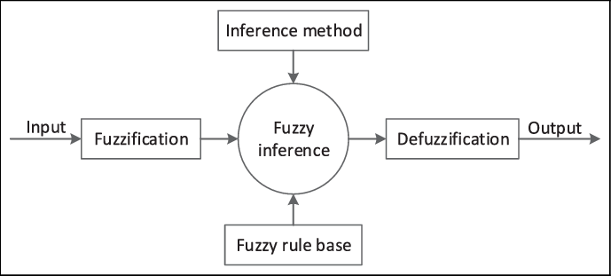

Fig. Fuzzy Logic Architecture

Fuzzy Logic systems are made up of four main components that work together to process imprecise or uncertain data:
Fuzzification:
- It is the process of converting precise input values (such as temperature or pressure readings) into fuzzy sets.
- Fuzzification converts crisp inputs—precise values measured by sensors, such as temperature or pressure—into fuzzy values using membership functions.
- These fuzzy values represent degrees of membership in different categories (e.g., "cold," "warm," or "hot"), enabling the system to handle imprecision effectively.

Rule Base/Knowledge Base:
- The knowledge base contains a set of IF-THEN rules and membership functions provided by experts.
- These rules govern the decision-making process by translating linguistic inputs into actionable outputs.
- These rules use natural language terms (like "high," "low," "warm") to describe conditions and actions.

Inference Engine:
- It evaluates the fuzzified input data and applies the relevant rules from the rule base.
- It finds which rules are most appropriate and then combines the results to generate a control action.
- This process is the core of decision-making in a fuzzy logic system.

Defuzzification:
- Once the inference engine processes the rules and generates fuzzy outputs, it converts these fuzzy results back into a precise, crisp value.
- This final step ensures that the system can take clear actions based on the fuzzy logic outputs.
- Several defuzzification techniques exist, and the choice of method depends on the specific system requirements.

By integrating fuzzification, a robust knowledge base, an inference engine, and defuzzification, the architecture of a fuzzy logic system provides a powerful framework for handling uncertainty and complexity in decision-making processes.

Common Types of Membership Functions:
Singleton:
- Represents a crisp value as a fuzzy value at one specific point.

Gaussian:
- Based on the Gaussian curve, this allows smooth transitions between membership degrees.

Trapezoidal or Triangular:
- It uses straight-line shapes to define how membership changes across a range of values.

Some/Key Applications:
Control Systems: In air conditioners and automatic braking systems, fuzzy logic adjusts operations based on sensor inputs like temperature or proximity.

Applications of Fuzzy Logic:
Fuzzy logic is used in many fields where precision isn’t always possible:
Aerospace: Fuzzy logic is used in spacecraft and satellite altitude control systems.
Automotive: It's applied in speed control and traffic management systems.
Natural Language Processing (NLP): It allows for handling approximate matches and vague inputs in search engines and other NLP applications.
Control Systems: It is integral to many modern control systems including expert systems and robotics.

Advantages of Fuzzy Logic:
Fuzzy logic systems has several benefits which are as follows:
Handles imprecise or noisy data: Whether the data is distorted or not completely accurate, it can still make sense of it.
Easy to design and understand: Unlike many complex algorithms, fuzzy logic systems are straightforward and simple to implement.
Efficient for complex problems: Fuzzy logic mirrors human reasoning, so it’s great for solving problems in many areas like decision-making or control systems.
Low memory requirements: The algorithms are simple and can operate with little data.

Disadvantages of Fuzzy Logic:
While fuzzy logic has many strengths, it also comes with some challenges:
Ambiguity: Different researchers may propose different solutions to the same problem, making the approach less systematic.
Difficulty in proving correctness: Since fuzzy logic deals with uncertainty, proving that a system works as expected can be tricky.
Accuracy compromises: Because fuzzy logic deals with both precise and imprecise data, the system might sacrifice some level of accuracy.

Fuzzy Logic vs Binary Logic (Boolean logic/Crisp Logic):
Differences between fuzzy logic and binary (Boolean logic/Crisp Logic):
Binary logic: Operates with exact inputs, yielding TRUE or FALSE outputs.
Fuzzy logic: Allows for intermediate states, such as very much or little, for more realistic decision-making.
Example:


Example:
Given the universal set, U = {a, b, c, d, e} and the membership function (MF) for each element of the set as µ_{A}(a) = 0.2, µ_{A}(b) = 0.7, µ_{A}(c) = 0.4, µ_{A}(d) = 0.1 and µ_{A}(e) = 0. Write the fuzzy set A.

Solution: A = {(a, 0.2), (b, 0.7), (c, 0.4), (d, 0.1), (e, 0)}

Example:
Given U = {p, q, r, s}, µ_{A}(p) = 0.2, µ_{A}(q) = 0.7, µ_{A}(r) = 0.18, µ_{A}(s) = 0.15 and µ_{B}(p) = 0.3, µ_{B}(q) = 0.6, µ_{B}(r) = 0.15, µ_{B}(s) = 0.1. Write the fuzzy sets AՍB, AՈB, A^{C} and B^{C}.

Solution:
AՍB = {(p, max(0.2, 0.3)), (q, max(0.7, 0.6)), (r, max(0.18, 0.15)), (s, max(0.15, 0.1))}
= {(p, 0.3), (q, 0.7), (r, 0.18), (s, 0.15)}

AՈB = {(p, min(0.2, 0.3)), (q, min(0.7, 0.6)), (r, min(0.18, 0.15)), (s, min(0.15, 0.1))}
= {(p, 0.2), (q, 0.6), (r, 0.15), (s, 0.1)}

A^{C} = {(p, 1 - 0.2), (q, 1 - 0.7), (r, 1 - 0.18), (s, 1 - 0.15)}
= {(p, 0.8), (q, 0.3), (r, 0.82), (s, 0.85)}

B^{C} = {(p, 1 - 0.3), (q, 1 - 0.6), (r, 1 - 0.15), (s, 1 - 0.1)}
= {(p, 0.7), (q, 0.4), (r, 0.85), (s, 0.9)}

Example:
Consider U is the universal set and A is a crisp set like Fig. 1. Show the membership function (MF) graphically.

U

g h k
A

a b c
Fig. 1: Universal and Crisp set

Solution:
The membership function (MF) is shown in the following figure which is actually a characteristics function.
1
x
µ_{A}(x)
a b c g h k
Figure: Graph of MF

Example:
If U is the universal set and A is a fuzzy set like Fig. 1. Show the membership function (MF) graphically.

U

g k
A

a b
Fig. 1: Universal and fuzzy set
h
c

Solution:
The membership function (MF) is shown in the following figure.
1
x
µ_{A}(x)
a b c g h k
Figure: Graphical form of MF
0.5
0.25

Example:
Consider the following triangular, trapezoidal and Gaussian MF of Fig.1 to Fig.3 against fuzzy sets A, B, and C. Determine µ_{AՍBՍC}(x_{i}) and µ_{AՈBՈC} (x_{i}) graphically at x_{i} =3.
1
x
µ_{A}(x)
x = 3
Fig. 1: Triangular MF
0.2
1
x
µ_{B}(x)
x = 3
Fig. 2: Trapezoidal MF
1
x
µ_{C}(x)
x = 3
Fig. 3: Gaussian MF
0.8

Solution:
µ_{AՍBՍC}(x_{i}=3) = max(0.2, 1, 0.8) = 1
µ_{AՈBՈC} (x_{i}=3) = min(0.2, 1, 0.8) = 0.2

